Exercise 6

- Order all employees on the basis of the salary they drew.
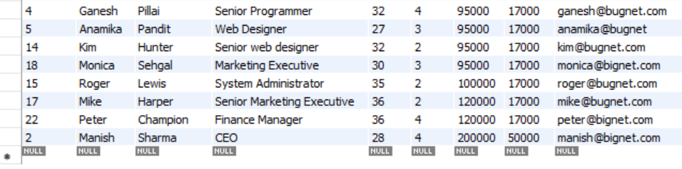
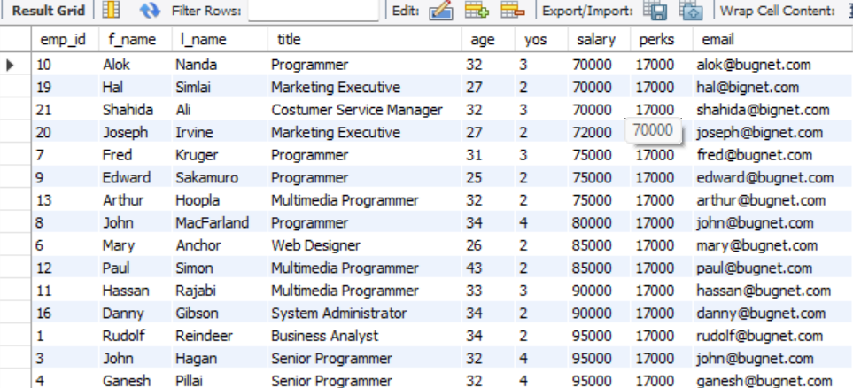
SELECT * FROM employee_data ORDER BY salary;

- List all employees in descending order of their years of service.
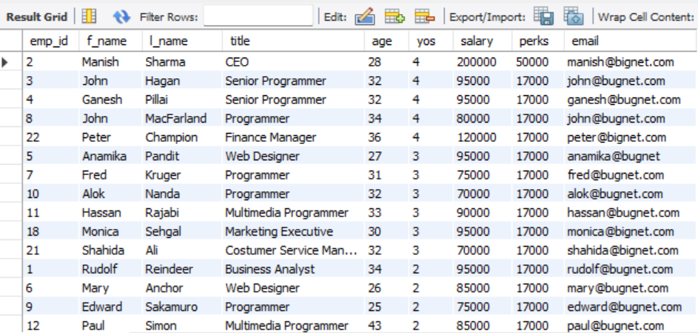
SELECT * FROM employee_data ORDER BY yos DESC;
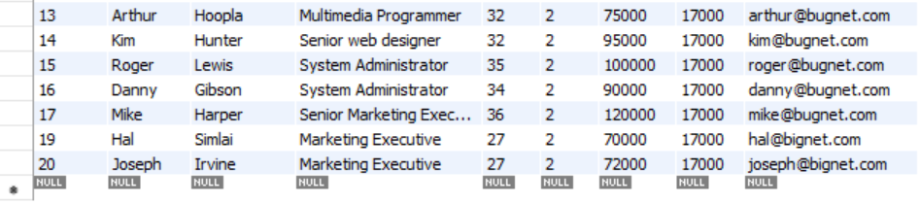

- What does the following statement display?
Select emp_id, l_name, title, age from employee_data order by title desc, age asc;
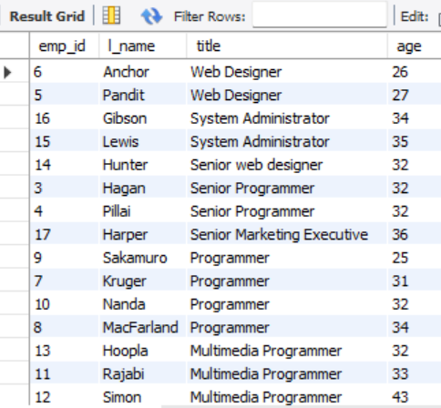

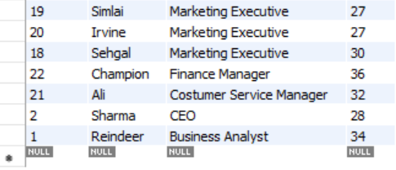

- Display employees (last names followed by first names) who hold the title of either “Programmer” or “Web Designer” and sort their last names alphabetically.
